DENNIS MOGAKA COM/18/18

***INSTRUCTIONS ;***

Open XAMPP ,myphpadmin and create new database and name it kd;

Import the sql file from SQL file at the root folder;

Table with name kdalumni is created and the first values inserted.

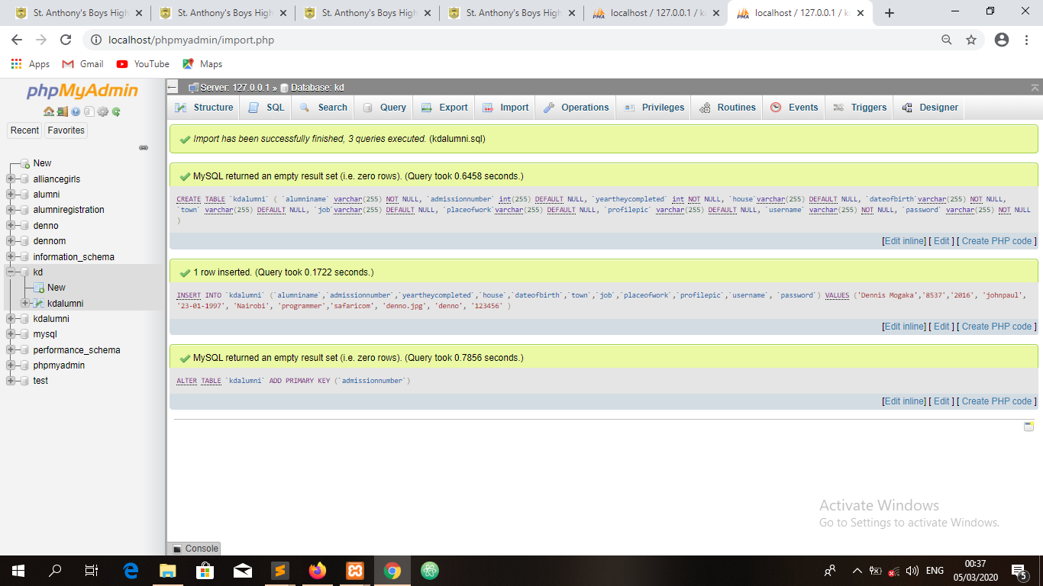

Open browser and navigate localhost/DENNIS MOGAKA COM 18 18/index.php to go to home page.

Move cursor to ALUMNI menu and you’ll get two drop menus.

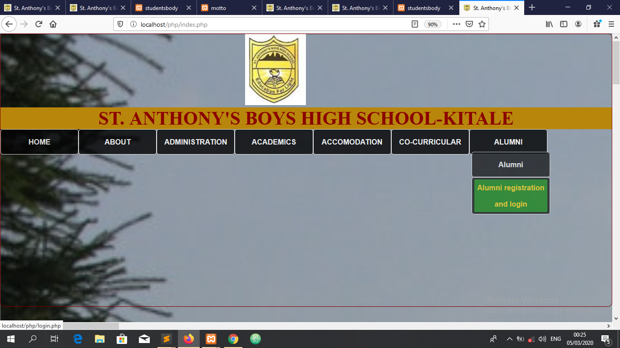

Go to alumni to view the photo, name admission number and year of completion of all registered alumni. since I already input first values, the details of the first registered alumni will appear.

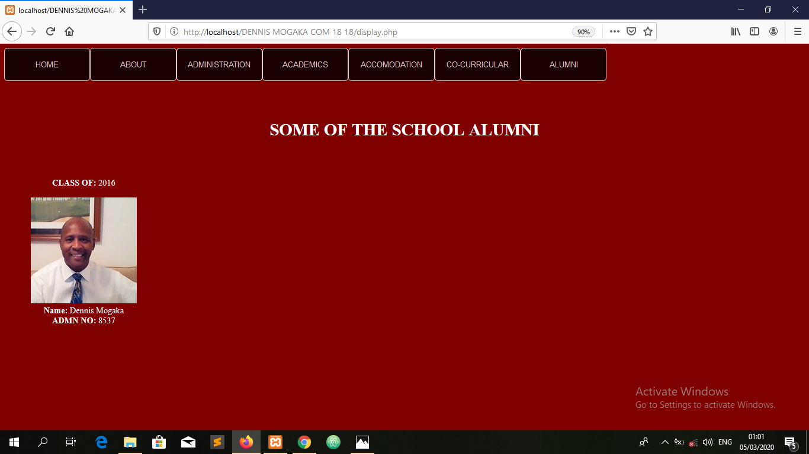

When you go to alumni registration and login menu, two forms will appear;the registration form which allows one to register and a login form which allows one to login.

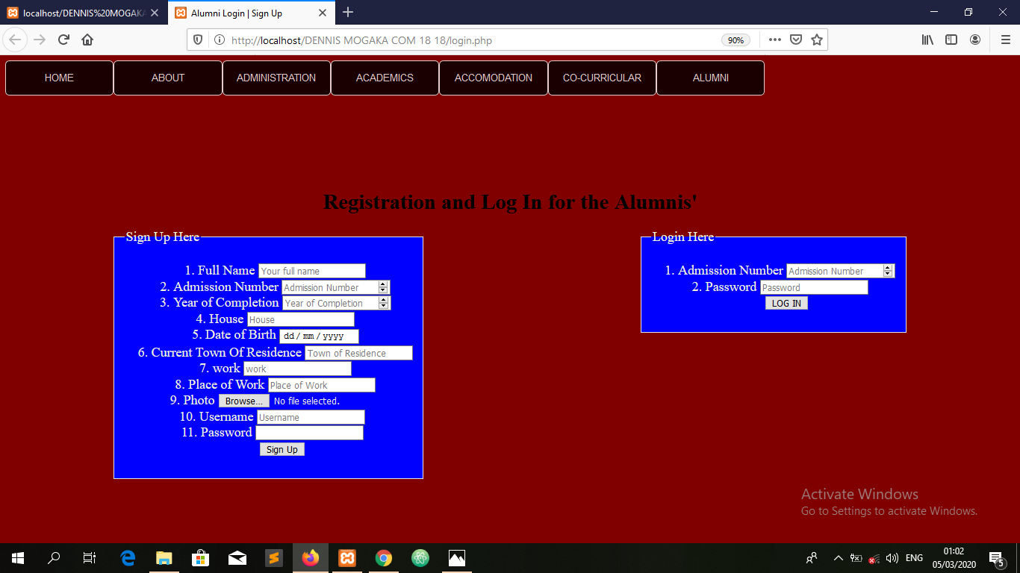

If you successfully register you will get a notification and if not successful you’ll also get a notification.

After successful login your profile will be displayed.

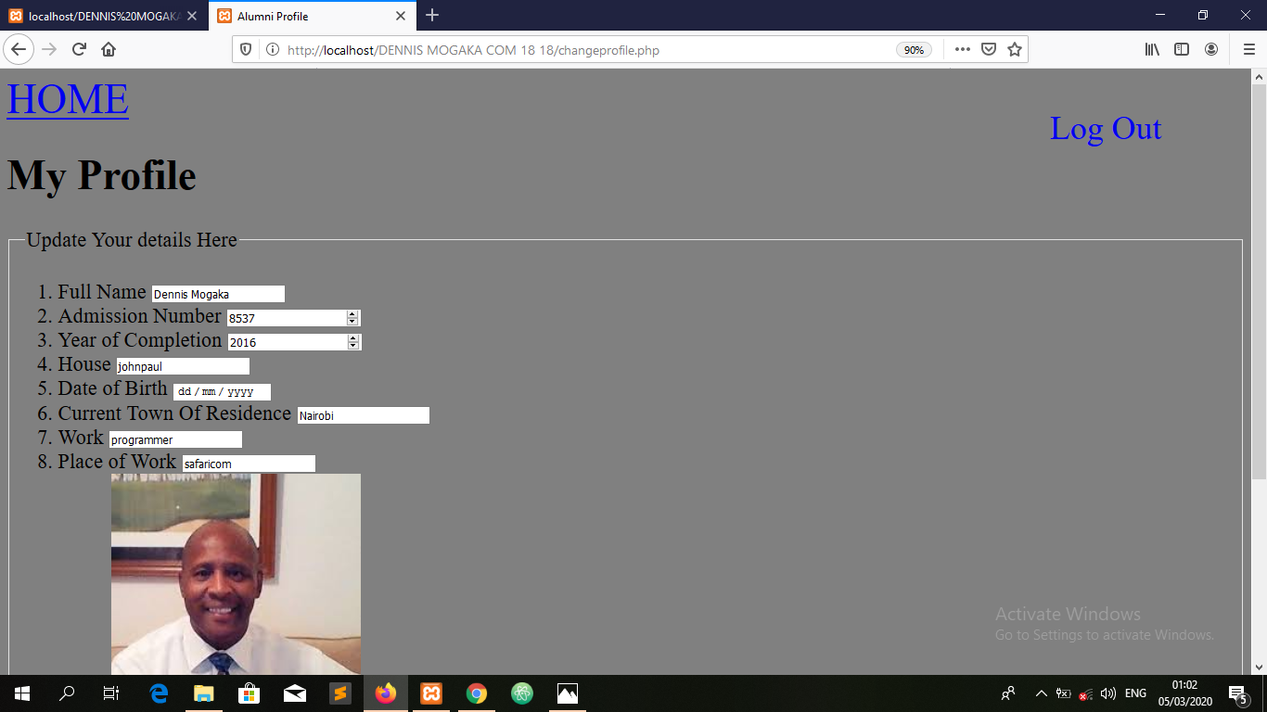

You can change anything and click update to update your profile.

You can logout by clicking the logout menu at the top right.